**M.Sc C.S - I**

**SEM I**

**E-Journal**

|  |  |
| --- | --- |
| **Roll No.** | 027 |
| **Name** | OJHA ABHISHEK DEVMANI |
| **Subject** | ADVANCED DATABASE SYSTEM |

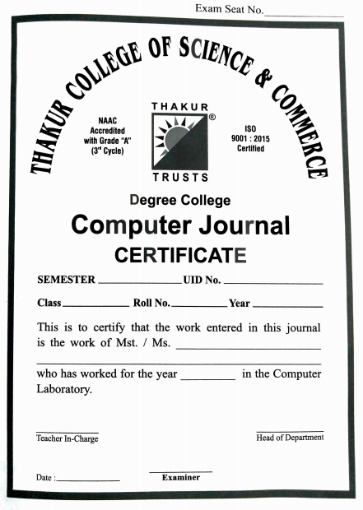

**027**

**21-12-2021**

**Ashish Trivedi**

**Vineet Khamrai**

**2021-2022**

**Ojha Abhishek Devmani**

**2021-2022**

**MSc-CS**

**Sem - I**



CERTIFICATE

This is here to certify that Mr. **OJHA ABHISHEK DEVMANI**, Seat Number **027** of M.Sc. I Computer Science, has satisfactorily completed the required number of experiments prescribed by the UNIVERSITY OF MUMBAI during the academic year 2021 – 2022.

Date: **21/12/2021**

Place: **Mumbai**

Teacher In-Charge Head of Department

**Vineet Khamrai** **Ashish Trivedi**

External Examiner

**INDEX**

|  |  |  |
| --- | --- | --- |
| **Sr. No.** | **Practical Name** | **Date** |
| **1** | For a given a global conceptual schema, divide the schema into horizontal and vertical fragmentation and place them on different nodes. Execute queries on these fragments that will demonstrate distributed databases environment. | 27-09-2021 |
| **2** | Place the replication of global conceptual schema on different nodes and execute queries that will demonstrate distributed databases environment. | 09-10-2021 |
| **3** | CRUD operation using MongoDB. | 18-10-2021 |
| **4** | Create different types that include attributes and methods. Define tables for these types by adding sufficient number of tuples. Demonstrate insert, update and delete operations on these tables. Fire suitable queries on them. | 23-10-2021 |
| **5** | Create a temporal database and issue queries on it. | 30-10-2021 |
| **6** | Create a table that stores the special data and issue queries on it. | 13-11-2021 |
| **7** | Create a table employee having dept_id as number datatype and employee_spec as XML data type (XM_Type). The employee_spec is a schema with attributes emp_id, name, email, acc_no, managerEmail, dataOf Joning. Insert 10 tuples into employee table. Fire the following queries on XML database. | 16-11-2021 |